MEMO

**FROM:** Edward Ma, W0057568, 701

**TO:** Bill Cunningham

**DATE:** 11-15-2016

**SUBJECT**: DBAS 1001 Assignment #6

* **Existing System Details:**
  + The Appointment Scheduling System Design documentation from Assg4 using the following files
    - assg4_MS_AccessTABLE.accdb
* **Statement of Requirements**:
  + to complete each of the tasks listed in the “Your Work section of this assignment;” on the assg6.docx
* **Analysis:**
  + ***ERD***  
    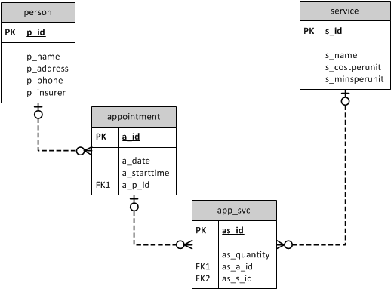
  + ***Data Dictionary***

| Object Name | Object Type | Datatype | Methods | Notes |
| --- | --- | --- | --- | --- |
| person | table | N/A | PK | The scenario dictates a need to track information on persons. Persons must be uniquely identified. |
| p_id | field | INTEGER | PK | Required to uniquely identify persons. |
| p_name | field | VARCHAR2(20) |  | The client requires tracking of persons’ names. The length spec for the field is 20 to accommodate typical names. |
| p_address | field | VARCHAR2(40) |  | Address required for billing purposes. Length spec based on average. |
| p_phone | field | CHAR(10) |  | Phone required. Fixed 10 to accommodate area code and prevent math. |
| p_insurer | field | CHAR(4) |  | Insurance name is required. Fixed for 4 for Acronym |
| appointment | table | N/A | PK,FK | Stores info re patient appointments. They must be uniquely identifiable. |
| a_id | field | INTEGER |  | Required to uniquely identify appointments |
| a_date | field | DATE |  | The date of the dental appointment with a patient. Date information will include day. month and year (MM/DD/YYYY) |
| a_starttime | field | DATE |  | The starting time of a patient appointment must be recorded. Date information will include hours and minutes (HH:MM) |
| a_p_id | field | INTEGER | FK |  |
| service | table | N/A | PK | Scenario requires tracking of the services offered at the clinic. Unique identification required. |
| s_id | field | INTEGER | PK | surrogate key to uniquely identify a service. |
| s_name | field | VARCHAR2(10) |  | The name of the service. Length spec based on average. |
| s_costperunit | field | INTEGER |  | The dollar cost of one unit of the service. |
| s_minsperunit | field | INTEGER |  | The minutes, in fifteen minute increments, to perform one unit of the service. |
| app_svc | table | N/A | PK, FK | The scenario requires tracking of the services provided during appointments. An app_svc record must be unique and must refer to an existing appointment and an existing service. |
| as_id | field | INTEGER | PK | Required to uniquely identify app_svc records. |
| as_quantity | field | INTEGER |  | The number of units of the service provided during the appointment |
| as_a_id | field | INTEGER | FK | A field is required to uniquely identify which appointment(a_id) is connected to this app_svc(as_id). INTEGER datatype to match appointment(a_id). |
| as_s_id | field | INTEGER | FK | A field is required to uniquely identify which service(s_id) is connected to this app_svc(as_id). INTEGER datatype to match service(s_id). |

* + ***Screenshot a Datasheet view of one of my tables***  
    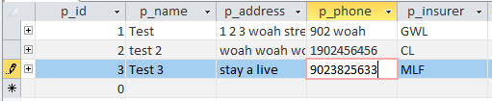  
    The little pencil indicate that the data is being inserted.
  + **the INSERT statement I used for one of my parent tables, one of my child tables, and one of my grandchild tables. This will prompt the User to enter the Data:**
    - INSERT INTO person (p_id, p_name, p_address, p_phone, p_insurer)   
      VALUES ([Client ID], [Client Name], [Client Address], [Client Phone], [Client Insurer]);
    - INSERT INTO service (s_id, s_name, s_costperunit, s_minsperunit)  
      VALUES ([Service ID], [Service Name], [Cost/Unit], [MinsCost/Unit]);
    - INSERT INTO appointment ( a_id, a_date, a_starttime, a_p_id )   
      VALUES ([Appointment ID], [Appointment Date], [Appointment Time], [Person ID]);
    - INSERT INTO app_svc (as_id, as_quantity, as_a_id, as_s_id)   
      VALUES ([Appointment Service ID], [# of Service Provider], [Appointment ID], [Service ID]);
  + ***Or Enter the Data Value INSERT SQL Query, for example:***
    - INSERT INTO person (p_id, p_name, p_address, p_phone, p_insurer )

VALUES (1, 'Billy Bob', 'HillyBilly St', 9023825464, 'MLF');

* + - INSERT INTO service (s_id, s_name, s_costperunit, s_minsperunit )

VALUES (1, 'cleaning', '250', '125');

* + - INSERT INTO appointment (a_id, a_date, a_starttime, a_p_id )

VALUES (1, #11/15/2016#, #11:02:00 AM#, 1);

* + - INSERT INTO app_svc (as_id, as_quantity, as_a_id, as_s_id )

VALUES (1, 250, 1, 1);

* + ***Insert Data Via Form View.***  
    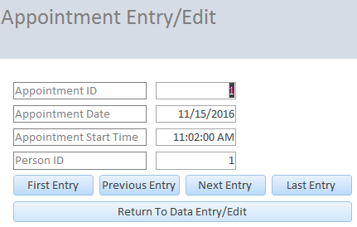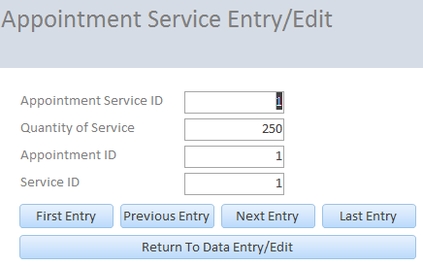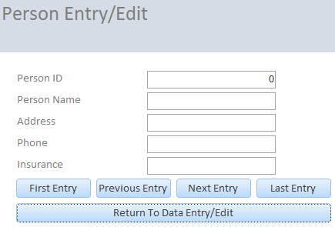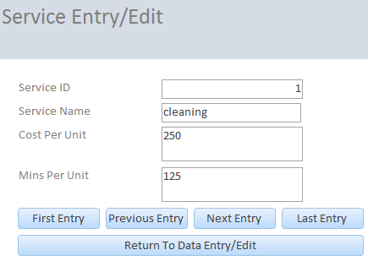
* **Recommendation:**
  + Please accept the demonstration as evidence of the per-specification functionality of the data entry application.